**Dokumentasi Final Project Java Spring Boot**

**Bus Booking Application**

1. **Entity Relationship Diagram**

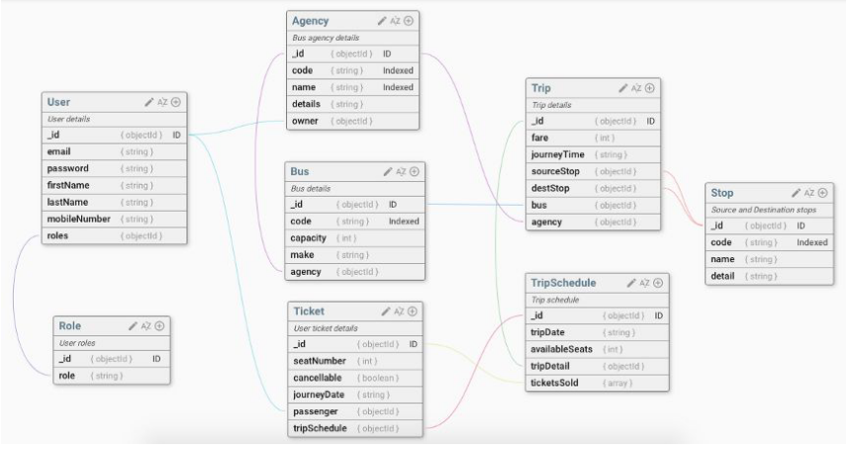

Gambar 1. ER Diagram Database

1. **DB Migration**
2. **Agency**

INSERT INTO `agency`(`code`, `details`, `name`, `owner_user_id`)

VALUES ("BDL","PT Angkasa Muda","Angkot Karang",1),

("BDL2","PT Angkasa Tua","Angkot Barang",1);

1. **Stop**

insert into stop values

(1, '1-2', 'Teluk', 'Karang'),

(2, '1-8', 'Cimeng', 'Sukaraja 1-8'),

(3, '1-3', 'Raja BasaI', 'Kedaton 1-3'),

(4, '1-2', 'Sukabumi', 'Sukarame 1-2'),

(5, '1-10', 'Tanjung Senang', 'Jati Agung 1-10');

1. **Trip**

INSERT INTO `trip` VALUES

(1, 15000, 15, 1, 1, 4, 1),

(2, 15000, 2, 1, 1, 4, 2),

(3, 15000, 3, 1, 1, 2, 3),

(4, 15000, 5, 1, 1, 4, 4),

(5, 15000, 4, 1, 1, 2, 5),

(6, 15000, 7, 1, 1, 3, 6);

1. **Role**

INSERT INTO `roles` (`name`) VALUES ('ROLE_USER');

INSERT INTO `roles` (`name`) VALUES ('ROLE_ADMIN');

1. **TripSchedule**

INSERT INTO `trip_schedule` VALUES

(1, 10, "2022-07-05", 1),

(2, 20, "2022-07-06", 2),

(3, 15, "2022-07-04", 3);

1. **Bus**

INSERT INTO `bus`(`capacity`, `code`, `make`, `agency_id`)

VALUES (20,"BDL01","20",1);

INSERT INTO `bus`(`capacity`, `code`, `make`, `agency_id`)

VALUES (15,"BDL02","15",1);

**C. List Services**

* 1. **User**
     1. **Signup** (/api/v1/user/signup/)

Method : **POST**

Request Body :

{

"email": "string",

"firstName": "string",

"lastName": "string",

"mobileNumber": "string",

"password": "string",

"role": [

"string"

],

"username": "string"

}

* + 1. **Get User by Id** (api/v1/user/{id}/)

Method : **GET**

* + 1. **Update User** (api/v1/user/{id}/)

Method : **PUT**

Request Body :

{

"firstName": "string",

"lastName": "string",

"mobileNumber": "string"

}

* + 1. **Delete User** (api/v1/user/{id}/)

Method : **DELETE**

* 1. **Auth** (api/auth/)
     1. **Authenticate**

Method : **POST**

Request Body :

{

"password": "string",

"username": "string"

}

* 1. **Agency**
     1. **Get Agency By Owner Id** (api/v1/agency/{userId}/)

Method : **GET**

* + 1. **Create Agency by Owner id** (api/v1/agency/)

Method : **POST**

Request Body:

{

"code": "string",

"details": "string",

"name": "string",

"ownerId": 0

}

* + 1. **Update Agency by Owner Id** (api/v1/agency/)

Method : **PUT**

Request Body :

{

"code": "string",

"details": "string",

"name": "string",

"ownerId": 0

}

* + 1. **Delete Agency** (api/v1/agency/{id}/)

Method : **GET**

* 1. **Bus**
     1. **Get Bus in Agency with Agency Id** (api/v1/bus/{id}/)

Method : **GET**

* + 1. **Create Bus for Agency** (api/v1/bus/{agencyId}/)

Method : **POST**

Request Body :

{

"capacity": 0,

"code": "string",

"make": "string"

}

* + 1. **Update Bus** (api/v1/bus/{id}/)

Method : **PUT**

Request Body:

{

"capacity": 0,

"code": "string",

"make": "string"

}

* + 1. **Delete Bus** (api/v1/bus/{id}/)

Method **: DELETE**

* 1. **Trip**
     1. **Get Trip by Agency Id** (api/v1/trip/{id}/)

Method : **GET**

* + 1. **Get Trip by two stop (**api/v1/trip/{sourceStopID}/{destStopID}/)

Method : **GET**

* + 1. **Create Trip (**api/v1/trip/)

Method : **POST**

Request Body :

{

"agencyId": 0,

"busId": 0,

"destStopId": 0,

"fare": 0,

"journeyTime": 0,

"sourceStopId": 0

}

* + 1. **Update Trip** (api/v1/trip/{id}/)

Method **: PUT**

Request Body :

{

"agencyId": 0,

"busId": 0,

"destStopId": 0,

"fare": 0,

"journeyTime": 0,

"sourceStopId": 0

}

* + 1. **Delete Trip** (api/v1/trip/{id}/)

Method **: DELETE**

* 1. **Ticket**
     1. **Get All Ticket** (api/v1/ticket)

Method : **GET**

* + 1. **Book Ticket** (api/v1/ticket)

Method : **POST**

Request Body :

{

"cancellable": true,

"journeyDate": "string",

"passegerId": 0,

"seatNumber": 0,

"tripScheduleId": 0

}

* + 1. **Update Ticket** (api/v1/ticket/{id})

Method : **PUT**

Request Body :

{

"cancellable": true,

"journeyDate": "string",

"seatNumber": 0,

}

* + 1. **Delete Ticket** (api/v1/ticket/{id})

Method : **DELETE**

* 1. **TripSchedule**
     1. **Get All TripSchedule by Date** (api/v1/tripschedule/filter)

Method : **POST**

Request Body:

{

"tripDate": "string"

}

* 1. **Stop**
     1. **Get All Stop** (api/v1/stop/)

Method : **GET**

* + 1. **Create Stop** (api/v1/stop/)

Method : **POST**

Request Body :

{

"code": "string",

"detail": "string",

"id": 0,

"name": "string"

}

* + 1. **Update Stop** (api/v1/stop/{id}/)

Method : **PUT**

Request Body

{

"code": "string",

"detail": "string",

"id": 0,

"name": "string"

}

* + 1. **Delete Stop** (api/v1/stop/{id}/)

Method : **DELETE**